Project Overview
Team 522’s project is to make a manufacturing device for students sponsored by Rockwell. We want to display the automated manufacturing process while providing an educational experience and make a tangible product that the student can take home with them. The team designed a system that builds a decorative metal button. This product was chosen by the team for its ability in demonstrating various manufacturing stages. The design consists of an assembly line where the product, in this case the metal pin, will be built from its raw material into a finished and personalized product. This will contribute to the engaging and learning process of the students/ or general viewers since they will be able to design their own pin, watch how it is being made and take it home with them. The design uses computer-aided design and testing software such as CAD and emulate3D to test the efficiency of the manufacturing process. The physical model uses Rockwell hardware alongside other parts.
Fig 1. Manufacturing Device Complete Assembly

Component description

Storage Silos
The storage silos are what stores the pin top, pin bottom and the mylar plastic for when they need to be placed in the die mold. In terms of sub parts, the pin top and pin bottom have three parts each; the silo, the piston and the cap. The piston for each is placed in the notch at the bottom of its respected silo and it should sit flush against the inner wall of the silo and the bottom of the silo itself. Once the piston is placed the cap can be placed on the bottom, making sure the pegs on the respective cap are aligned with the holes on the bottom of the silo. For the plastic silo, there is no piston, so the cap just needs to be aligned with the holes on the bottom of the larger plastic silo. The file name for the ramps aligns with which silo it needs to be attached to and there are pegs on the ramp that align with holes on the silo so the ramp can be attached easily and straight. Depending on print orientation, the bottom of the silo and ramps might need to be sanded to bond to the cap and silos when glued.
Fig 2. Storage silos with pistons, caps and ramps

Entry box
The entry box is comprised of two main pieces, the entry box and entry ramp, and a NEMA 17 stepper motor. The entry box does not attach to the frame with any hardware, it just slides onto the frame during assembly. The stepper motor is placed in its housing on the side opposite of the door hinge and secured using M3 screws. The ramp is pressed onto the stepper motor and the notch on the opposite side slides into the hole on the opposite side allowing it to be supported on both ends to reduce stress on the part and stepper motor.
Fig 3. Entry box with entry ramp and NEMA 17 stepper motor

Conveyor gantry
The gantry consists of the die mold we bought the gantry itself, gantry spacers and extrusion wheels. Three M5 screws are put into the recessed holes on the gantry and the gantry spacer is slid on followed by the extrusion wheels and secured with an M5 bolt. It's best to assemble the side with a single wheel on it last so it can be tightened onto the extrusion rod to ensure a tight fit. The die mold slides into the gantry and the locking pins are dropped into the holes in the die mold on both sides. There is a little wiggle room to allow for correction when pressed to ensure the system does not break under the pressing force.

Fig 4. Conveyor gantry that includes the die mold, gantry, gantry spacers, extrusion wheels and the M5 bolts and nuts

Orientation System
The orientation system consists of an outer and an inner cylinder. The inner cylinder will be lowered to the gantry when it reaches this step of the process and will be rotated to properly orient the paper design. This is crucial so that when the pin gets pressed in the next station it can be right side up every time an item is produced.
Fig 5. Orientation system with outer and inner cylinder

Press System
The press system consists of a linear actuator and a 3D printed mechanism that holds the top of dye the dye mold. This must be positioned so that the top of the dye mold rotates and hits the bottom of the dye mold correctly. There is a rocker switch that has ON and OFF positions, this controls the UP and DOWN motion of the press. There is a push button titled STOP LINEAR ACTUATOR, this button will stop the linear actuators motion in either direction.
Fig 6. Press system with press mount to support the linear actuator

Ejection gantry
The ejection gantry is similar to the conveyor gantry in terms of how it uses M5 nuts and bolts to attach the ejection gantry spacers and the extrusion wheels to the gantry to allow it to slide across the frame. The stepper motor fits into the housing on the gantry and is attached with four M3 bolts. The ejection gear is attached to the stepper motor, making sure the gear is aligned with the slot in the gantry for the rack. The ejection arm rack and ejection arm shell must be attached together, making sure the top and bottom are aligned. Then the rack system can fit into the hole, making sure the teeth on the rack are aligned with the teeth on the gear attached to the motor.
Fig 7. Ejection gantry system that includes the ejection gantry, NEMA 17 stepper motor, ejection gear, ejection arm rack/shell, ejection gantry spacers and extrusion wheels

Conveyor motor
The NEMA 23 motor is placed in its housing and secured using M3 bolts. The conveyor gear is slid on the stepper motor, making sure the middle of the teeth is aligned with the middle of the extrusion rod to make sure the belt is straight. A special clamp is used on this side to be able to attach the limit switch to the system.
Fig 8. The Conveyor motor housing and limit switch

Tension Housing
The tension housing keeps the conveyor belt tightened to ensure correct positioning of the gantry when moved and avoid quality, safety and accuracy issues in the process.
Fig 8. Tension Housing

Electrical System
Schematic
Fig 10. Electrical Schematic

Notes: This schematic was made using Fritzing.
- Motor drivers are different model numbers than what are shown in schematic. The pin connections and all other connections are identical.
- Switch positions for DM442 drivers: S2 OFF, S1 ON, S3-S7 ON.
- Switch positions for DM542 driver:
- Linear actuator does not have optical sensor connected (3 extra wires attached to linear actuator)
- Power supplies: +24V DC, +12V DC, external 5V USB connection for Arduino
- Buttons 1 – 9 from left to right.

Rockwell’s Emulate3D Software:
Emulate3D is software developed by Rockwell to simulate industrial automation systems. They call it a “digital twin” to a 3D physical model. It is instrumental for testing, predicting future performance and issues, and simulation. We used Emulate3D to simulate our fully automated system that our previous design was expected to have. This helped us understand another software that we normally would not have access to and how to troubleshoot problems before we built our physical model.
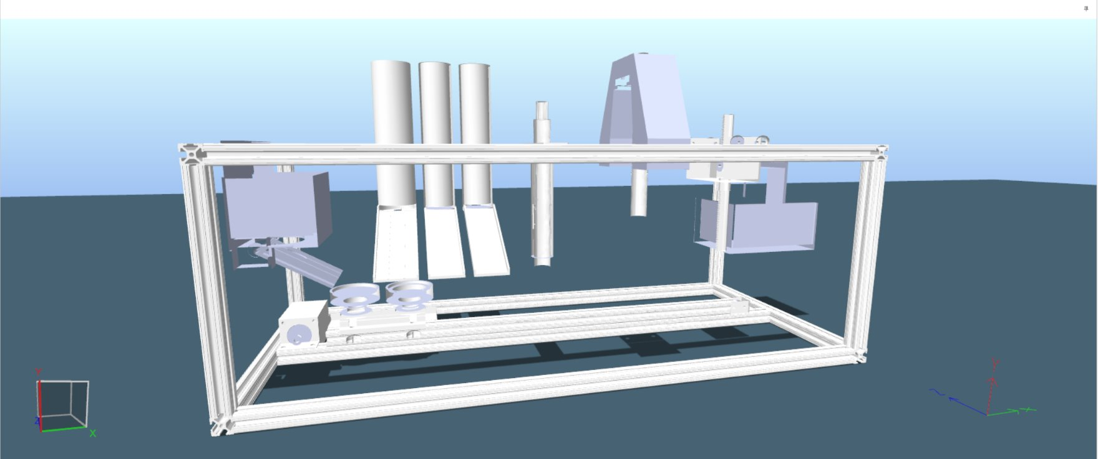
Fig 11. Emulate3D model
Before opening the software, that Rockwell will need to give you access to, you need to start by review different training solutions from the “Sim3D store”: https://store.sim3d.com/training_paths/academic_controls_testing_training_path
Some important training videos and modules that can be found here and that our team used to achieve some basic motions of our system were: Fundamentals (starting with User Interface), Running the Simulation, CITM Basics.
If using parts created in a CAD software such as Creo Parametric or SolidWorks, a Rockwell sponsor will need to upload them into Emulate3D since the accounts provided to us did not allow us to do from our side. We sent each of our parts/assemblies in the file format of IGES to make it easier for the sponsor. Send it to a sponsor as soon as you can to avoid time delays. Once the CAD parts are in the software, you will need to manipulate it to the desired location for your design. Steps on how to achieve this were found in the training modules.
When it came to getting certain parts to move, we used “Kinematic Prismatic Joints” to move up, down, left, or right. We also used a “Kinematic Cylindrical Joint” because we needed a part to move up, down and rotate. These joints also needed motors and controllers. The controllers are chosen based on what motion you need to accomplish in QuickLogic. QuickLogic is a built-in coding used for, in our case especially, when you want parts to be in a specific position in time. To use this, you must first use “Flow Control”, set an axis to every part that needs to move and open QuickLogic in Procedure.
For help with using Joints, Motors, Controllers, Flow Control, or QuickLogic, the Rockwell sponsors should give you access to the web store with examples of problems that may occur:
https://store.sim3d.com/
Some tips for overall Emulate3D – the “Vault” are where files are kept, name the files accordingly and update them regularly since you cannot work on them simultaneously with another team member. Always save your work since if you are not actively working on Emulate3D, it will close the session or disconnect. Work in a small sized project unless told otherwise by the sponsors. It will take time to understand Emulate3D and all its functions/commands, but when completed, you will have experience with another software that other people don’t.

Operation
Once the device is fully assembled, it will be placed on a level and unmoving surface that is unobstructed to any viewers. The device’s power supplies will be connected to available outlets by the administrator of the experience. After viewing participants return their given paper designs, the entry gate will be manually opened, and a single design will be placed inside with the entry gate being closed after its placement.
A button labeled “Top Position” will be pressed which will move the die mold to the storage silos where a button top will fall into the die mold’s left side. The button labeled “Design Position” will be pressed which will move the die mold to be directly in front of the entry gate. A button labeled “Ramp Gate” will then be pressed, and a stepper motor will open the entry gate ramp which will allow the paper design to enter the die mold. A fourth button labeled “Orient” will then be pressed which will move the die mold to the orient section with the design underneath the orientation arm; the administrator will then lower and rotate the arm to properly orient the paper design in the mold. Afterwards, a button labeled “Bottom & Plastic” will be pressed which will move the die mold to a placement underneath two silos. The administrator will then manually bring down the button bottom into the right side of the die mold and the mylar plastic onto the left side atop the paper design.
The button labeled “Press Positions” will then be pressed which will move the die mold such that the top side of the die mold is underneath the linear actuator presser position. The press switch will then be set in the “Down” mode which will activate the linear actuator and cause it to press the design onto the top. The “Stop Press” button will be pressed after the top of the die mold is in the fully pressed position visualized. The linear actuator will remain still after the “Stop Press” button is pressed until the press switch is interacted with again. The press switch will then be set in the “Up” mode which will move the linear actuator back up until it reaches its starting position at which point it will cease movement.

Troubleshooting: This section should suggest remedies for possible issues that may arise.
CAD – Any issues arising with the CAD, the best thing to do is confirm dimensions from the products being used and the products you will need. If any issues arise with working SolidWorks, go to an expert in the field like Professor Larson or research online like videos. When issues arise with assembling, being sure that all the files are in the same folder and that individual parts fit together would be helpful. The team used PTEG filament for some 3D printed parts like the press holder and orientator. Some parts will take some time to print because they are large files. Making sure you use a big enough printer that can handle that filament is essential.
Electrical – Many issues can arise with the electrical portion of this project due to the immense hardware and software parts. When it comes to a hardware component, testing every part before using it or assembling is a first step. Since the schematic is included, double check that if something isn’t working when it should. Also, wiring can be tricky, so double checking that the wires are connected would be another good step. Asking for help from professors like Hooker could be helpful if you have looked at other options. For the software portion, detailed code with comments is accessible. For code trouble shooting; Arduino Forums on stepper motors are extremely helpful. Stackexchange and a plethora of other resources exist for controlling stepper motors using arduino. Firgelli Linear actuator (the brand used in this system) has great resources available for controlling their machines using Arduino. Use all resources available such as professors, professional advisors, and peers. Some people are better at coding than others, do not be afraid to ask for help when it comes to electrical and software troubleshooting.
Emulate3D – Some issues are listed in the Emulate3D section, but to clarify, refer to the training videos/solutions if any issues with emulate whether general or specific. The sponsors are helpful, but remember they have full-time jobs. There are some videos on YouTube that could help, but the best resources are the training videos/solutions and from the web store directly. Rockwell may give you access to 24/7 tech support, which could help when other options have been explored.

Code (stepper motor control):
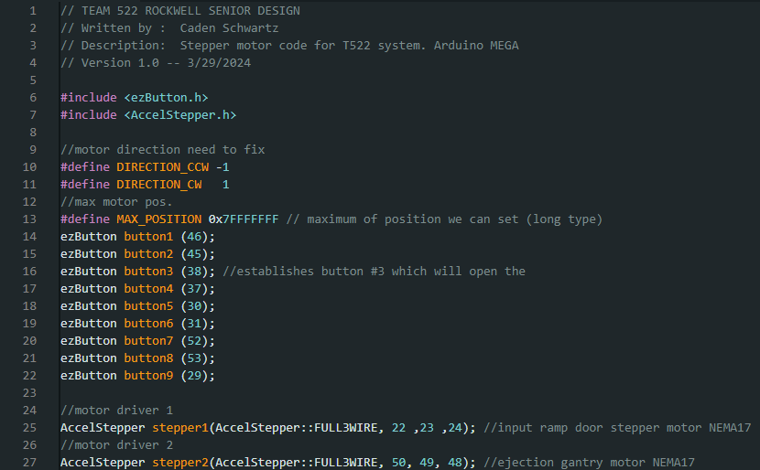
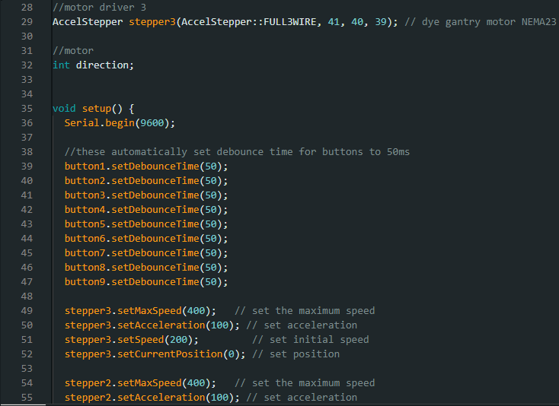
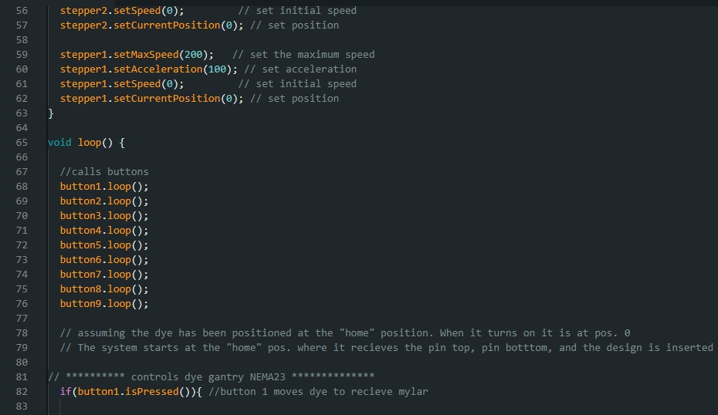

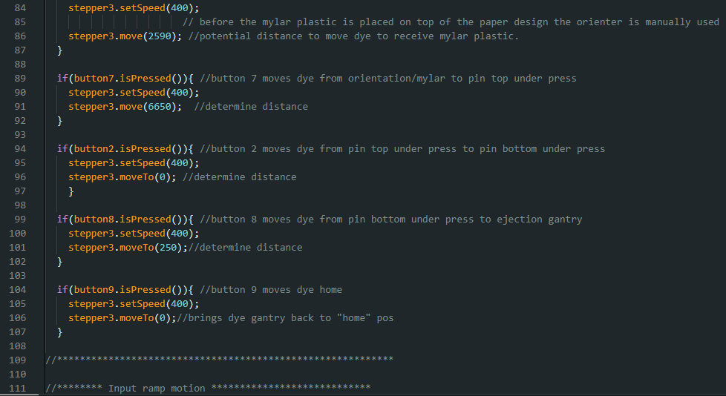
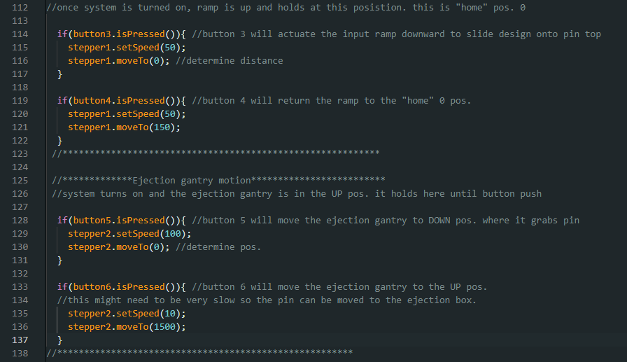
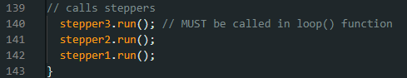

Code (Linear Actuator):
